Mariano Marcos State University
College of Agriculture Food and Sustainable Development
City of Batac

TERM PAPER
(Pechay Production)

In Partial Fulfilment of the Requirements in
Agri 10

Submitted by:
Niño Paul Anthony L. Ronduen
BSA I-B

Submitted to:
Dr. Artemio Alcoy

PECHAY PRODUCTION

I. INTRODUCTION
Pechay (Brassica chinensis L.) is an erect, annual herb, about 15-30 cm tall in vegetative stage. Ovate leaves are arranged spirally and spreading. The petioles are enlarged and grow upright forming a subcylindrical bundle. Inflorescence is a raceme with pale yellow flowers. Seeds are 1 mm in diameter and are reddish to blackish brown in color. Pechay can be grown from low to mid elevations throughout the year.
Pechay is used mainly for its immature, but fully expanded tender leaves. The succulent petioles are often preferred part for food. It is used as main ingredient for soup and stir-fried dishes. In addition, pechay is better known as napa cabbage or Chinese cabbage in the United States, a crisp leafy vegetable used in a variety of Asian cuisines. The tough outer leaves of the cabbage are common in soups and stews, while the tender inner leaves are often eaten raw, roasted or used in kimchi. Each serving of pechay is low calorie and low fat, which makes it ideal for dieters.
In the Philippines, it is popularly known as Pechay or Petsay. It is one of the most often used vegetable in many Filipino dishes. Petsay is added to Filipino stews such as nilagang baka (boiled beef) or bulalo (boiled beef shank). People who choose to eat it raw can enjoy it tossed in a salad mixed with other greens. The conventional farming practice entails production processes and postharvest activities that include the use of chemicals as part of the main inputs that boost pechay productivity and resilience. However, due to the accounted negative effects on the environment and human health, this practice is now being lessened in replacement of the so-called "farming with a conscience" that is organic agriculture (OA).
However, the productivity of pechay per unit area is quite low as compared to the developed countries of the world. Among the various factors involved nutrient supply is an important inputs for realizing higher pechay yield and its nutrient content. Experimental evidence showed that the response of pechay is high to nitrogen application and moderate to phosphorus application. Several authors reported the importance of organic and inorganic fertilizer on the productivity and nutritional quality of pechay. The information regarding organic and inorganic fertilizer on pechay yield and its nutritional quality is very meager in our local climatic condition.
II. DISCUSSION
A. General Aspects
Origin and Distribution
Pechays originated from China, inhabiting a vast amount of the land. It has been introduced to Europe and is farmed for people who love the rich bitterness of this plant. There are some who believe that pechay originated from Africa but pechay is from China, that’s for sure.
Soil and climatic requirements
Pechay thrives in well-drained, moisture-retentive, loamy soils well supplied with organic matter. It does not grow well in highly acidic soil. The ideal soil pH ranges from 5,5 to 6,5 and it should not be allowed to drop below 4,5. The optimum temperatures for growth and development are from 18 ° to 20 °C. It is fairly resistant to frost and can survive temperatures as low as –3 °C without damage. Pechay is also adapted to a wide variety of weather conditions and can as such
be grown throughout the year in most regions.
Soil Management
A well-prepared seedbed is important and preparation must commence well before transplanting. Pechay require a soil with a pH of 6.0–6.5 for best growth. This can be achieved by applying dolomite or lime at a rate of 2–5 t/ha when cultivation is commenced. In most areas cabbages are transplanted into raised beds to reduce the effect of heavy rain, which would waterlog the soil. Beds should be formed as soon as possible to allow them to stabilize before transplanting.
B. Cultivation Practices
1. Propagation
Cabbage is propagated from seeds.
2. Soil preparation
The land should be clean and it should be cultivated 8 weeks before planting.
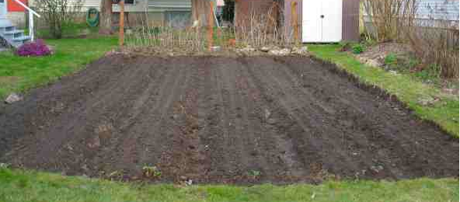

The ground must be ploughed deeply, immediately before planting, with a disk harrow or other suitable implement to a depth of 450 to 600 mm. The soil should be fumigated 2 weeks before planting time if necessary, to control nematodes.
3. Planting
A 1-ha production area requires 3 kg seeds. Pechay can either be sown directly in soil or transplanted. Direct seeding is carried out by broadcasting or by sowing in rows. Cover seeds to a depth of about 1cm by raking or spreading additional top soil. Water immediately after sowing.
Plant spacing should be 10 cm between plants and 20 cm between rows.

4. Transplanting
Moisten thoroughly the seedbed a day before pricking out the seedlings for transplanting. This will facilitate easy pricking out of seedlings for transplanting from the seedbed to minimize root injury. Gently prick out the seedlings and transplant them in the prepared plots or in pots, after which water adequately the plots or pots.
If transplanted, sow seeds initially in seedbeds. Transplant seedling 2-3 weeks after sowing at a distance of 10 cm between plants and 20 cm between rows. Transplant preferably in the afternoon and water immediately. Mulch with grass clippings or rice straw.
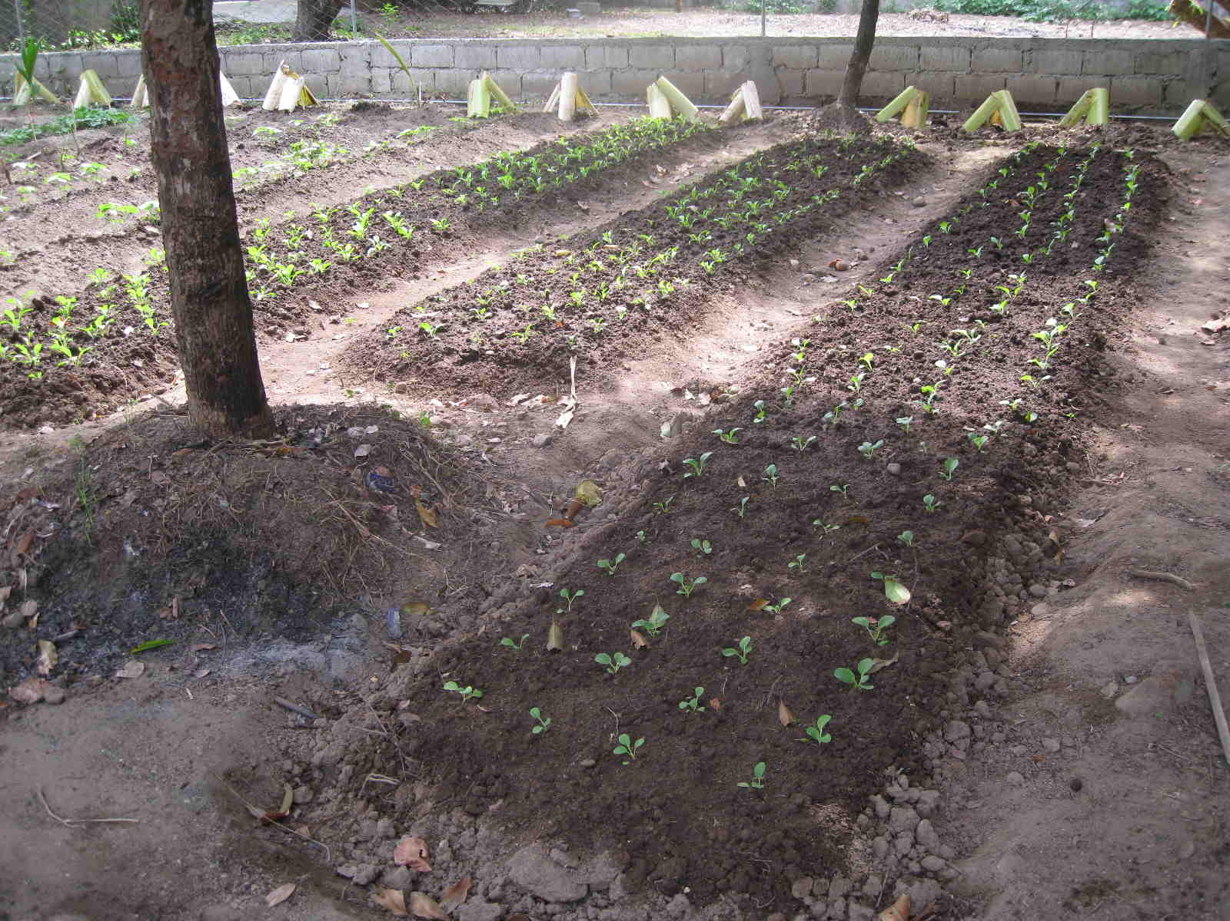

Spacing usually depends on the variety of pechay to be planted but the common distance used is 15 cm between hills and 20 cm between rows.
5. Spacing
Spacing depends on soil type, cultural methods, and the district. Where two rows are planted per bed, a plant spacing of 75 cm is used on a 1.2 m bed. A spacing of 40–60 cm is used on single-row plantings where the rows are 1 m apart.

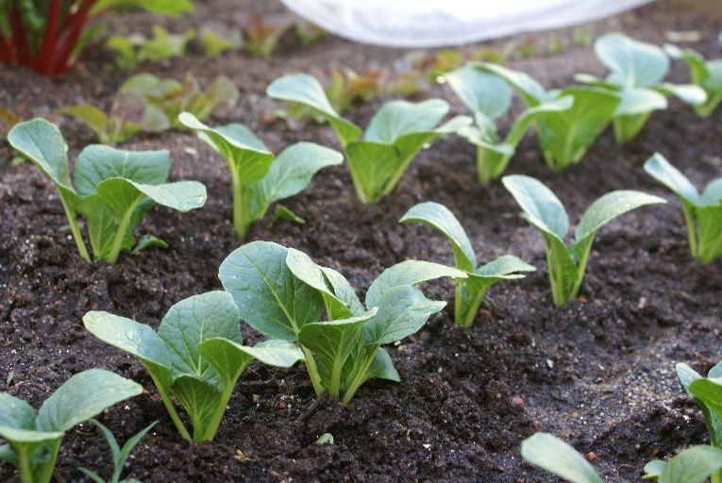

Narrower plantings are used where smaller sized cabbages are produced. A favoured density is 20,000 plants/ha.
6. Irrigation
Pechay need regular irrigation to ensure rapid growth and evenness of maturity. They can be irrigated by moveable spray lines, travelling irrigators or solid set, or, if the soil is suitable and water available, flood irrigation.
Pechay grown in beds will require more irrigation than those grown on the flat. Soil type and weather will also influence the frequency of irrigation. The use of tensiometers or other measuring equipment will improve yields and reduce water costs.
7. Fertilization
Apply seedling with starter solution using (46-0-0) at the rate of 2 tbsp/gal of water. Side-dress along the rows at the rate of 1 tbsp/plant one week after transplanting.
Fertilizer programmes should be based on soil analyses and should be developed for each field. Pechay requires 200 to 250 kg nitrogen per hectare. Nitrogen is supplied in split applications, where half to two-thirds are broadcast and ploughed in just before planting. The first application is made together with phosphorus and potassium. The remainder is applied as a side dressing 2 to 3 weeks after transplanting and again 3 weeks later or applied (once-off) at about 6 weeks. A top dressing of 300 kg LAN should be applied approximately 4 weeks after transplanting and again 4 weeks later if required.
8. Irrigation
Pechay need regular irrigation to ensure rapid growth and evenness of maturity. They can be irrigated by moveable spray lines, travelling irrigators or solid set, or, if the soil is suitable and water available, flood irrigation.
Pechay grown in beds will require more irrigation than those grown on the flat. Soil type and weather will also influence the frequency of irrigation. The use of tensiometers or other measuring equipment will improve yields and reduce water costs.
9. Weed Control
Weeds are controlled mechanically or by hand as well as chemically by applying registered herbicides. Mechanical cultivation should be done during land preparation until the plants are about half-grown. The first cultivation should be done 2 to 3 weeks after transplanting
10. Pest and disease control
Damping-off, soft rot and clubroot are the most important diseases of pechay, while diamonback moth and aphids are the major insect pests. These pests can be controlled by spraying hot pepper extract. When seedling begin to wilt, reduce watering immediately. Uproot and bum disease-infected plants to prevent spread of diseases. Cultivation is also necessary to minimize weeds.
a. Diseases
Black rot (Xanthomonas campestris) occurs in all areas and affects both seedlings and adult plants. It is the major disease of pechay and prevents the production of good quality heads during the warmer months of the year. Areas such as Bathurst, which are much cooler than coastal regions, become important suppliers during the summer.
Symptoms: Infection occurs on the leaves through marginal waterpores or wounds. The bacteria move down the leaf veins into the stem and then invade other leaves. The movement of the bacteria causes the leaf to turn yellow, then brown and finally dry out. Movement is usually in a V-shape.
Black rot is encouraged by warm, moist weather and rapidly growing soft tissue. It is carried both in and on the seed, and in crop debris. It can survive from year to year in the soil on leaves from diseased crops. Older plants carry the infection and it is transferred to young plants. Insects, water droplets, drainage water and windblown dust help spread this disease.
Control: Treat seed with hot water. Sterilise the seedbed. Avoid using seedbeds where crucifers have been grown before. Remove infected plants, and rotate crucifer crops on a 4 year pattern. Bury all crop residues as deeply as possible. Control biting and sucking insects, which can spread the disease.
Downy mildew (Peronospora parasitica)
Irregular yellow patches on leaves which turn light brown in color; fluffy gray growth on the undersides of the leaves.
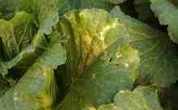

Control: Remove all crop debris after harvest; rotate with non-brassicas; application of appropriate fungicides may be required if symptoms of disease are present
Rhizoctonia disease (Rhizoctonia spp.) occurs throughout New South Wales and affects all stages of growth.
Symptoms: Rhizoctonia causes damping-off in young seedlings, while older seedlings become stunted and the soft tissue at ground level dies, leaving the symptom known as ‘wire stem’. Older plants are prone to stem rot and root rot. Leaves usually take on a purplish red colour. The disease is favoured by cool, wet conditions and is spread by wind-carried spores. Contaminated soil is a source of infection.
Control: Seedbed sterilization. Wire stem can be checked in the seedbed by drenching the base of the plant with a registered chemical. Crop rotation of 4 years also assists.
Alternaria leaf spot (Black spot, Gray spot) Alternaria brassicae
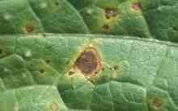
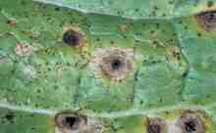
Small dark spots on leaves which turn brown to gray; lesions may be round or angular and may possess a purple-black margin; lesions may form concentric rings, become brittle and crack in center; dark brown elongated lesions may develop on stems and petioles.

Management: Plant only pathogen-free seed; rotate crops; applications of appropriate fungicides control disease when present
Club root (Plasmodiophora brassicae) occurs mostly in the Sydney metropolitan area and Bathurst district but is also present in other districts. It is the most important disease of crucifer crops.
Symptoms: Swellings develop on the tap root, secondary roots and even parts of the underground portions of the stem. Roots are often spindle-shaped with thick centres and tapered ends. Diseased roots often decay before the end of harvest. Plants are usually stunted and wilt on hotter days. Plant collapse occurs with advanced decay and enlargement of roots. High soil moisture, acid soil and temperatures between 18.5°C and 25.5°C favour the disease. The fungus survives for long periods in the soil and on diseased crop trash. Club root is spread by infected seedlings, windblown soil and contaminated farm machinery.
Control: Use disease-free seedlings and rotate crops so that crucifers are not grown for 3–4 years in the same ground. Lightly infested soil can be treated with lime, which reduces the symptoms in the plant. Drenching the root zone at transplanting with a suitable registered fungicide is also effective.
Turnip mosaic virus or ringspot virus disease is caused by turnip mosaic virus transmitted on seed and by green peach aphids (Myzus persicae).
Symptoms: There is a yellow ringspotting of the younger leaves, which later become mottled with light and dark green rings and blotches. These symptoms are most prominent in temperatures over 18°C. In lower temperatures the virus shows a definite black ringspotting of the outer leaves. The disease is spread by the green peach aphid feeding on infected plants and weeds then transmitting the disease to healthy plants. Aphids acquire the turnip mosaic virus after 10 seconds of feeding on infected plants, and transmit it after 5 seconds of feeding on healthy plants.
Control: Plant disease-free seedlings, produce seedlings away from infected plants, avoid planting near diseased crops or residue, and remove all cruciferous weeds as these carry the virus. Regular spraying will help control green peach aphid populations and reduce the spread of the virus. The manufacturer’s directions regarding rates and the interval between last application and harvest must be observed.

Flea beetle (Phyllotreta spp.)
Small holes or pits in leaves that give the foliage a characteristic “shothole” appearance; young plants and seedlings are particularly susceptible; plant growth may be reduced; if damage is severe the plant may be killed; the pest responsible for the damage is a small (1.5–3.0 mm) dark colored beetle which jumps when disturbed; the beetles are often shiny in appearance.
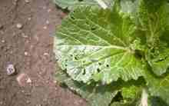
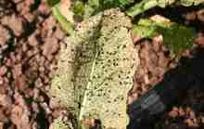

Management: In areas where flea beetles are a problem, floating row covers may have to be used prior to the emergence of the beetles to provide a physical barrier to protect young plants; plant seeds early to allow establishment before the beetles become a problem - mature plants are less susceptible to damage; trap crops may provide a measure of control - cruciferous plants are best; application of a thick layer of mulch may help prevent beetles reaching surface; application on diamotecoeus earth or oils such as neem oil are effective control methods for organic growers; application of insecticides containing carbaryl, spinosad, bifenthrin and permethrin can provide adequate control of beetles for up to a week but will need reapplied.
b. Insect Pests
Cutworms (Agrotis spp.) are stout, uniformly coloured, black, grey or reddish-brown caterpillars about 40 mm long when fully grown. They feed at night on the stems and foliage of plants. They are found in the top 25 mm of soil and close to the damaged plant. Seedling plants may be destroyed and parts of crops may have to be replanted. Cutworms are often more prevalent in low-lying areas after rain.
Control: Spraying the soil at the base of the plants with a registered chemical.
Black beetles (Heteronychus arator) are shiny black beetles, about 13 mm long, which may attack seedlings at about ground level, making ragged tears in the stem tissue. They are normally found in grasslands, and most damage is sustained when crops are planted into ground previously under pasture. They are found only in coastal areas and are active mainly in spring and early summer.
Control: There are two methods of control: baiting before transplanting, or spraying the soil at the base of the plants at planting and then 2–3 weeks later with a registered insecticide.
Aphids: Grey cabbage aphid (Brevicoryne brassicae) and green peach aphid (Myzus persicae). The grey cabbage aphid may occur in very large numbers and its feeding can cause distortion of leaves and stunting of the plants. The green peach aphid does not occur in large numbers, but it is important as the vector of the virus diseases cabbage ringspot and cauliflower mosaic.
Control: Regular spraying. To prevent the insect from transmitting virus disease to plants by feeding, spray the insects when populations are building up. The disease is transmitted within 5 seconds of the commencement of feeding.
Cabbage white butterflies (Pieris rapae) are probably the principal pest of crucifer crops, and are most active during spring and autumn. The yellow eggs are laid on the underside of the leaves, and the young, velvety green larvae (caterpillars) feed here. The fully grown larvae, which are about 30 mm long, are usually found on the upper leaf surfaces. The green or brown pupae are usually found attached to the leaves.
Control: A program of rotating chemicals and avoiding the use of a chemical from the same chemical family in succession is essential for the control of this insect and Plutella species. The publication Integrated Management of Diamondback Moth in Crucifers — The Handbook, by the National Diamondback Moth Project Team, is essential reading for better control of cabbage white butterfly and diamondback moth.
Diamondback or cabbage moths (Plutella xylostella) are a major pest of crucifers. The adult is a small brown moth, active at night and hiding by day in the leaf litter at the base of the plants. The small yellow eggs are laid in clusters along the ribs and the lower parts of the plants. The first instar larva mines within the leaves. Later instars feed on the undersurface or in the inner leaves, often producing a windowpane effect. When fully grown the larvae are about 8 mm long and, if disturbed, fall from the leaf and hang on a thread. They pupate in silken cocoons in sheltered parts of the plant.
Control: As for cabbage white butterflies.
Budworms (Helicoverpa spp.) may cause severe damage in some years, particularly during autumn. The buff-coloured moths lay their eggs singly on the leaves, and the larvae (budworms) bore into the heart of the cabbage. The larvae are about 40 mm long at maturity and are conspicuously striped. The basic colour may vary from brown to red, yellow or green. Their habit of feeding within the heart makes them difficult to control.
Control: Regular spraying to kill the budworm just after hatching from the egg and before it has time to become established in the centre of the cabbage plant.
Harvesting
Harvest as early as three weeks after planting or between 30-40 days after sowing. Harvest preferably in the afternoon to minimize postharvest losses.

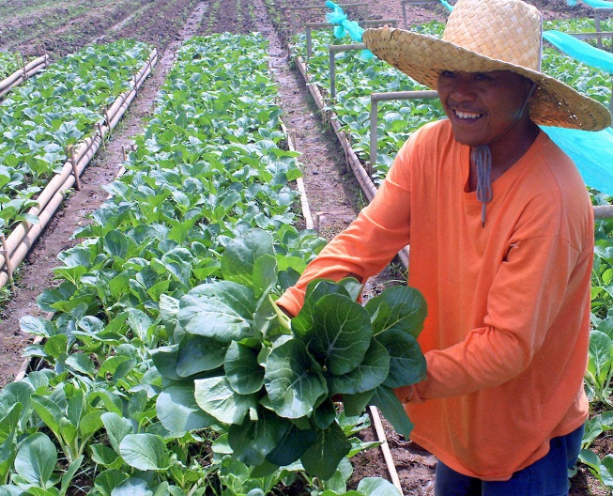

Upon harvesting, wash the plants, trim old leaves and remove roots. Grade according to size and quality, and pack in strong rigid containers with holes at the sides to allow aeration. Pack with the base of the plant to the sides of the baskets. Maintain turgidity by lining the basket with paper.
C. Post-Harvest Handling
Harvested produce should always be removed from direct sunlight and transported to the packing shed as soon as possible. Cabbage and leafy greens are particularly susceptible to wilting and other damage from high temperatures. When there is a delay of more than an hour or two between harvest and packing, a water drench or spray arrangement can help prevent dehydration and overheating.
1. Sorting and grading
The injured leaves should be removed.
2. Packing
Cabbage is packed in mesh pockets or sold loose.
3. Storage
The optimum storage temperature for cabbage is 0 °C and relative humidity of 90 % to 95 %. Cabbage to be store should be mature and disease-free and should not have been exposed to prolonged frost or cold. Further trimming may be necessary, mainly to remove the discoloured butt upon removal from storage.
The appropriate storage conditions should be established quickly following harvest to assure maximum storage length. When placed in cold storage, the heads should be packed loosely in crates to allow for proper ventilation around the heads. Heads of certain cultivars should be stored in an upright position to safeguard them against becoming misshapen.
4. Transport
Care must be taken that trucks are not overloaded on the bottom layers of produce are crushed. Generally, the produce should be covered with a sheet to prevent frosting or desiccation, but on warmer days, when sweating and heating might occur, the sheet should be left off.
5. Marketing
Pechay is sold in the Philippines fresh produce markets and also exported, mostly by commercial farmers.

III. CONCLUSION
Pechay requires sufficient irrigation. It should be grown in areas where rainfall is well distributed throughout the year, especially if it is to be raised on commercial basis. It grows during both the rainy and dry seasons, although it grows best during the cool months of the year. In order to make them grow faster, the soil around them should be cultivated and kept constantly moist.
Pechay is a short-season crop; one can have several harvests a year. Pechay is not very choosy as to where it should be grown. It can be grown throughout the Philippines, whether in small scale or extensively for commercial purposes. Pechay is a leafy vegetable that needs regular watering and the soil should be all drained, highly fertile, friable and rich in organic matter. Pechay should not be exposed to strong winds, especially when they are maturing, because strong wind can either uproot the plant or destroy its leaves. Neither should it be exposed to extreme heat, because the leaves will wilt due to faster evaporation of moisture. Pechay does not need plenty of sunlight to provide the much needed energy for the manufacture of food

IV. REFERENCES
http://davaoagribiz.da.gov.ph/tipsdl/vegetables/pechay_production.pdf
http://www.daff.gov.za/docs/Brochures/brochureCabbage.pdf
https://www.plantvillage.com/en/topics/chinese-cabbage/infos/diseases_and_pests_description_uses_propagation
http://www.scribd.com/doc/8310848/Chapter-4
http://www.darfu4b.da.gov.ph/pechay.html
http://ijagcs.com/wp-content/uploads/2012/05/128-138.pdf
Diza.C.F.2011.Supervise Farming Program in Organic Pechay Procuction.
www.pac.edu.ph/how many organic and inorganic apply in pechay production.

